Bank Group Credit Dynamics:
Regional, Sectoral, and Temporal Analysis

Project Overview:
- Bank Group Credit Dynamics: Regional, Sectoral, and Temporal Analysis examines how credit extended by Scheduled Commercial Banks (SCBs) in India varies across bank groups, population segments (rural, urban, metropolitan), and credit sectors (agriculture, industry, housing, personal) over time.
- The project cleans and harmonizes RBI groupwise credit tables into a tidy fact table, builds an interactive Power BI dashboard to visualize trends and concentrations, and produces evidence-based recommendations for policymakers and bank strategists.

Primary Objective
Assess temporal patterns and cross-sectional differences in SCB credit to identify where credit growth is concentrated, which bank groups drive sectoral shifts, and where regional imbalances or concentration risks exist.
- Analytical objectives
- To compute total credit and growth rates by bank group, region (rural/urban/metropolitan), sector, and year.
- To quantify how much of overall credit growth is driven by changes in volume versus changes in composition across sectors and bank groups.
- To identify recurring seasonal patterns and any abrupt shifts or regime changes in lending behaviour.
- To compare growth, share, and volatility across bank groups; identify top performers and laggards.
- To evaluate rural–urban–metropolitan disparities in credit access and growth rates.
- Data quality and reproducibility objectives
- To clean, normalize, and transform raw RBI tables into a tidy fact table with a full cleaning log and code/Power Query steps.
- To harmonize credit type labels, bank group names, and time formats so analyses are consistent and repeatable.

Source Description
The Dataset is maintained by India Data Portal (ISP) and is provided by RBI(Primary source) captures information on the credit extended by scheduled commercial banks in India to various population groups, bank groups and occupation groups. The Dataset covers various types of credit such as agricultural credits, personal loans, housing loans and loans to the industrial sectors etc.,
RBI releases information about the number of accounts, credit limit and amount outstanding categorised per population group, bank group and occupation under each district yearly.

Source Link
The Source link is
https://indiadataportal.com/p/reserve-bank-of-india/r/rbi-groupwise_credit_by_scbs-dt-yr-vvi

Time Line
The data set is created 2 years ago (2024) and last modified by 2025. The dataset contains credit limit data from 2019 to 2025. And the data is being updated yearly.

Domain
The domain of the data is Finance->Financial Inclusion.

Problem statement
- To map total credit by bank group across states, districts, and population segments (rural, urban, metropolitan) to identify geographic lending patterns.
- To measure year-wise changes in credit volumes to reveal long-term trends and recent shifts.
- To compare current credit levels with historical baselines to pinpoint regions and bank groups experiencing significant credit decline.
- To classify regions and bank-sector pairs into safe, moderate, critical, and over-exploited categories based on utilization and growth metrics.
- To decompose credit growth into volume and composition effects to understand whether growth is driven by sectoral shifts or overall expansion.
- To quantify sectoral composition (agriculture, industry, housing, personal) by region and bank group to detect structural changes in lending.
- To compute concentration and risk metrics (top-3 share, Herfindahl-Hirschman Index) to identify high-exposure bank groups and sectors.
- To produce an interactive dashboard with slicers and drilldowns for Year, Bank Group, Region, and Sector to support stakeholder exploration.

4. Attribute (Columns/Features) Details:
Attribute Name | Data Type | Description
Year | Number | Year of the credit
Region | Text | Region of the Bank
State | Text | Sate the bank located
District | Text | District of the band
Population Group | Text | Location type
Bank Group | Text | Type of bank
Occupation group | Text | Type of sector the loan was given
Occupation subgroup | Text | Subtype of the sector
Number of accounts | Number | No. of accounts lent money in particular Bank
Amount credit | Number | Amount of loan
Amount Outstanding | Number | Amount that to be paid by the sectors

5. Tools & Technologies
- Excel: Data cleaning, transformation, scenarios and Pivot Tables.
- Power BI: Data modelling, DAX calculations, visualization, and interactive dashboard creation.

6. Data Pre-Processing

6.1. Data Cleaning and Data Transformation
- The dataset has 10 Lakh plus records from the year 2013 to 2025, to ensure consistency, 2024- and 2025-year data only considered for analysis.
- The refined dataset consists of 348786 records.
- The Credit_ID Categorial column was added for readability.
- All categorial columns are cleaned and trimmed.
- All columns are assigned with appropriate datatypes.
- Validated for the null and blank values. Removed duplicates.
- Excel Functions used:
  - Clean, Trim and Proper.
- Calculated columns UtilizationRate is added for structured analysis.
  - UtilizationRate= OutStanding/CreditLimit

  - Outstanding → the current balance or exposure.
  - CreditLimit → the maximum sanctioned credit for that account.
  - UtilizationRate → shows how much of the available credit is being used.

7. Data Modelling and DAX

7.2. DAX
- Dax measures and calculated columns are created for the analysis as follows:
- Measures
Total_Credit_Limit | Sum of lending amount over the years
Total_Outstanding | Sum of Outstanding over years
CreditChangeAbsolute | Difference of credit change over the years 2025 and 2024
CurrentCredit | Total of Credit of year 2025
PreviousCredit | Total of Credit of year 2024
Share Of Change (BankGroup or State) | Share of Change measure that shows how much each BankGroup or State contributes to the overall change in credit between two periods (e.g., YoY)
Top3_Share_Sector | Top 3 BankGroups by credit within sectors
HHI_Sector | purpose: concentration index (sum of squared shares) by sectors
YoY Credit Percent | Year-over-Year growth rate in credit, current year’s credit exposure to the previous year’s, expressed as a percentage change.
Utilization | Portfolio_Utilization =  DIVIDE( [Total_Outstanding], [Total_Credit_Limit], 0 )

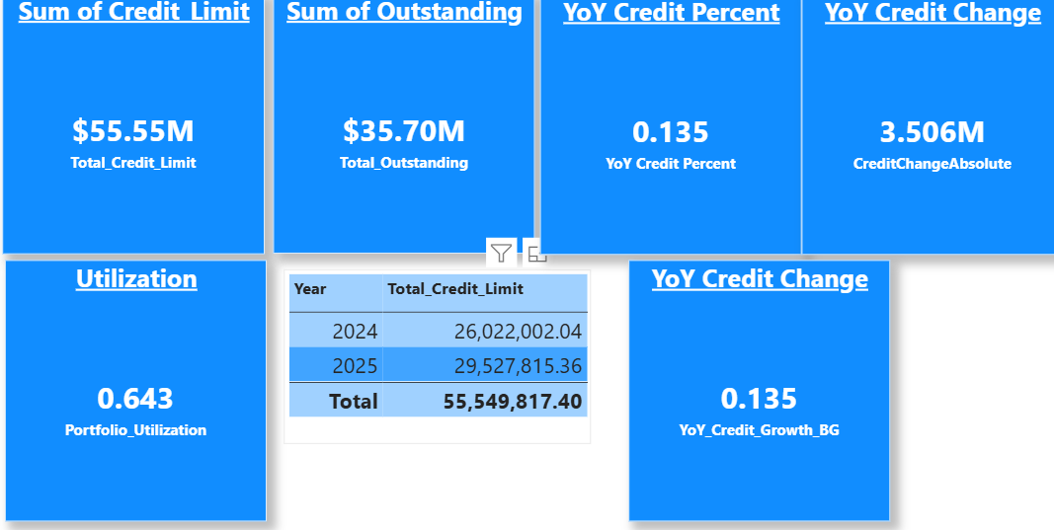
- Calculated columns
The following calculated columns are added.
- YoY_Credit_BG
This compares each BankGroup’s credit exposure in the current year vs the previous year and expresses it as a percentage change.
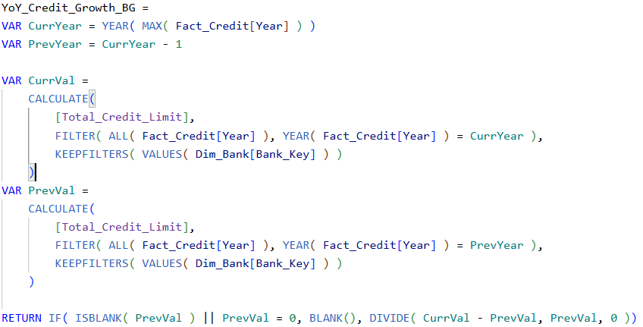
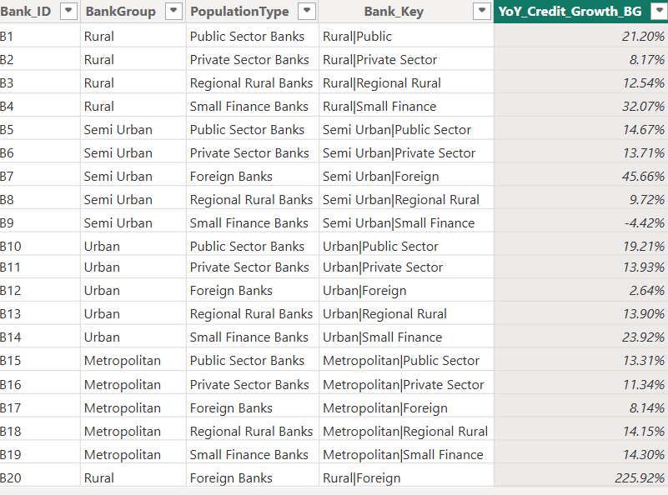

- High_UtilizationFlag
- HighUtilFlag = IF( Fact_Credit[Utilization Rate (Outstdg as % of Limit)] > 0.75, 1, 0 )

7.1. Data Modelling
- The original dataset was split into fact and dimension tables for structured analysis.
- Fact and dimension tables were created from the original dataset to support scenario modelling and descriptive analysis.
- Fact_credit contains following attributes
Credit_ID
Year
Reg_ID
Reg_Key
Sec_ID
Sec_Key
Bank_ID
Bank_Key
No. Of Accounts
Credit_Limit
UttilizationRate
ScenarioOutstanding
ScenarioUtilization
Outstanding
- From Fact_credit, Region, State and Districts and copied to separate sheet and normalized Region key Reg_Key is created by merging the Region,State and District content by delimiter.
- TRIM([@Region]) & "|" & TRIM([@State]) & "|" & TRIM([@District])
- Reg_ID is the text column, created with Flash fill of Excel by entering the first-row data as R1.
- Fact_Credit Table as well as changed accordingly.
- The same Trim and Concatenation is used to create the Reg_Key column in the Fact_Credit Table.
- The Reg_ID column is created in Fact_Credit and ID is Pulled to the table by XLOOKUP.
  - =XLOOKUP([@Reg_Key], Dim_Region[Reg_Key], Dim_Region[Reg_ID], "")
- Now, the categorial columns, Region, State and Districts are deleted from the Fact_credit Table.
- In the same way, Dim_Bank and Dim_Sector tables are created and ID and Keys are mapped into the Fact_Credit.
- Dim_Region
Reg_ID
Reg_Key
Region
State
District

- Dim_Sector
Sector_ID
Sec_Key
Sector
Sector_SubGrouop

- Dim_Bank
Bank_ID
Bank_Key
Bank_group
Population_Type
Established relationships between the central Fact_Credit table and supporting dimension tables (Dim_Bank, Dim_Sector, Dim_Region).
- Defined cardinality:
  - One-to-many relationships from each dimension table to Fact_Credit.
  - Each Bank, Sector, and Region can have multiple credit records in Fact_Credit.
- Created lookup tables where necessary:
  - Dim_Bank provides descriptive attributes such as BankGroup and PopulationType.
  - Dim_Sector organizes Sector_Group and Sector_SubGroup classifications.
  - Dim_Region supplies geographic context (District, Region, State).
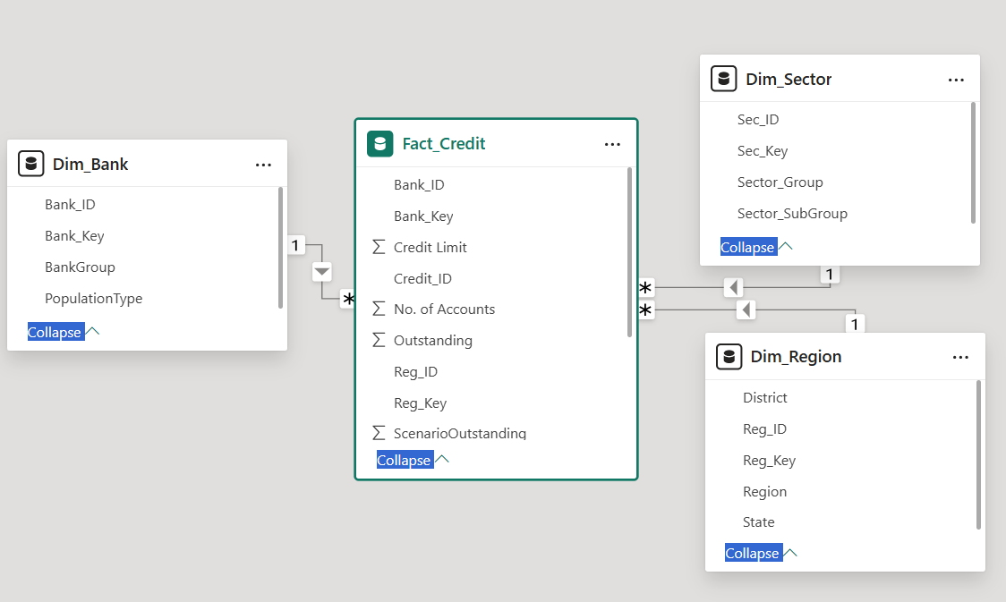
- Keys and foreign keys:
  - Fact_Credit contains Bank_ID, Sec_ID, and Reg_ID as foreign keys.
  - Dimension tables hold corresponding primary keys (Bank_Key, Sec_Key, Reg_Key) for referential integrity.
- Schema design: Implemented a star schema with Fact_Credit at the center and dimensions surrounding it, enabling efficient slicing, aggregation, and scenario analysis.
- Purpose: Supports descriptive statistics, scenario modeling, and geographic/institutional breakdowns in PivotTables and Power BI dashboards.

8. Analysis and Visualizations

8.1. Credit Across States and Bank Groups
- This visual is showing the credit exposure of bank groups such as Metropolitan, Rural, Urban and Semi-Urban throughout the states of India.
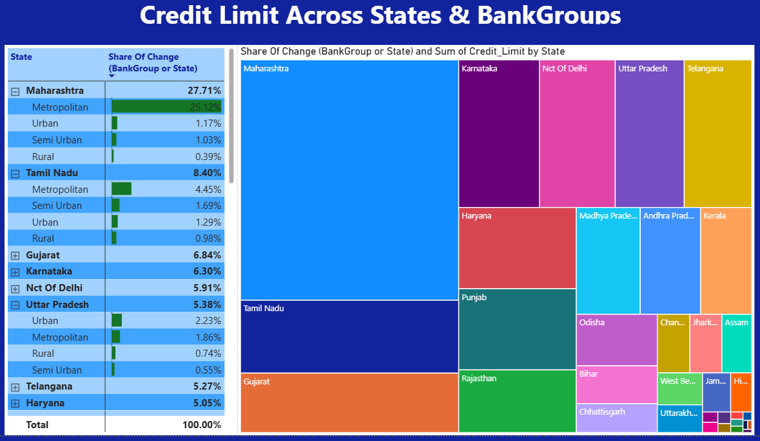
Insights
- Maharashtra (27.7%), Tamil Nadu (10.3%), and Gujarat (7.0%) together account for roughly 45% of the portfolio’s recent share-of-change.
- Metro and urban centres are the primary drivers of that growth, with metropolitan contributions notably large in Maharashtra, Tamil Nadu, and Uttar Pradesh.
- The portfolio’s recent growth is highly concentrated in a few states and metropolitan centers; immediate priorities are to quantify counterparty concentration within those states, stress-test top contributors, and pursue targeted geographic diversification to reduce systemic vulnerability.

8.2. Lending versus Outstanding over BankGroups
- The chart shows identical values for Sum of Outstanding and Sum of Credit Limit across Metropolitan, Urban, Semi Urban, and Rural — Metropolitan dominates (~20M), then Urban (~7M), Semi Urban (~5M), Rural (~3M). That pattern implies either very high utilization (≈100%)

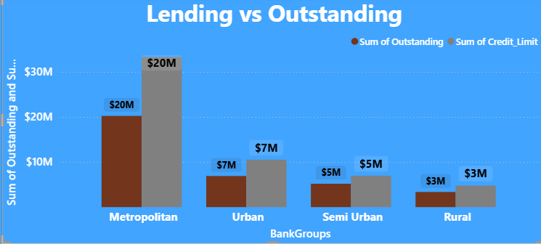
Insights:
- High rollover risk — renewals or limit increases are required to maintain lending; any refusal to renew will immediately reduce active exposure.
- Concentration: Metropolitan accounts for the majority of portfolio exposure.
- Metropolitan concentration — Metropolitan holds the largest exposure (~20M), roughly 50%+ of total portfolio shown, making the portfolio highly sensitive to metro-level shocks.
- Uniformity across segments — Similar utilization across Urban, Semi Urban, and Rural suggests systemic behavior (policy or market) rather than isolated pockets of drawdown.

8.3. Credit Exposure and Utilization over Sectors
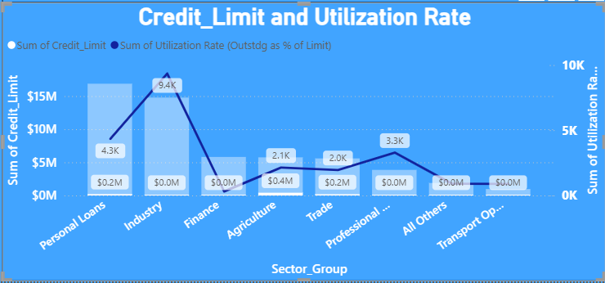
Insights:
- Industry is the dominant exposure with the largest credit limit and the highest utilization signal;
- Personal Loans and Agriculture show meaningful exposure but much lower utilization in absolute terms.
- Concentration risk: Industry and Personal Loans together represent the largest share of sanctioned limits; shocks in these sectors will move portfolio metrics materially.
- Hotspots with limited scale: Professional Services and Transport show higher utilization rates despite smaller absolute exposure; these sectors can be early indicators of stress that may escalate if left unchecked.

8.4. Matrix for YoY Credit Percentage vs Regions/BankGroups
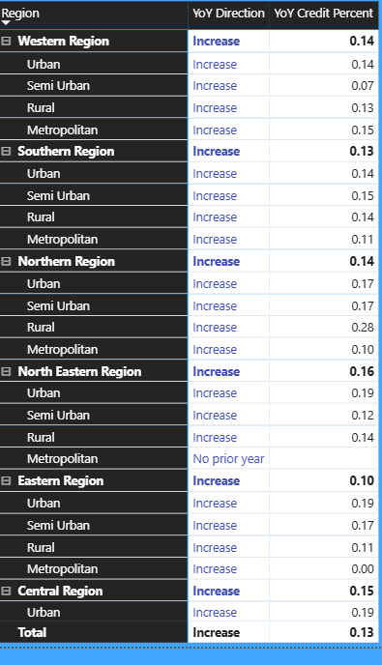
- The visual shows broad YoY credit growth across all regions, with an overall YoY credit increase of 13%.
- Growth is fairly uniform across metropolitan, urban, semi-urban and rural subregions, but clear hotspots and data gaps stand out most notably very strong rural growth in the Northern region and a missing/zero metropolitan value in the Eastern region.

8.5. State-Level Account Concentration and Distribution
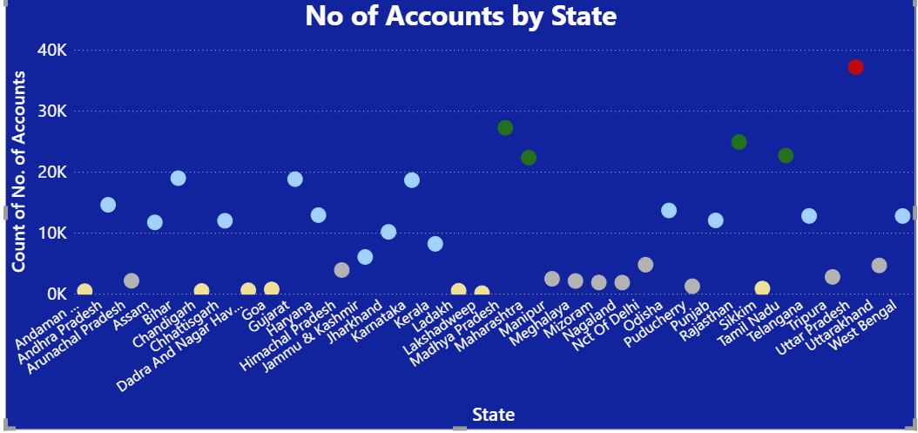
- Top states dominate — a small number of states hold the largest share of accounts (one state near 40K), creating geographic concentration in customer base.
- Wide dispersion — many states have low account counts, indicating uneven market penetration and potential untapped opportunity.
- Clustered mid-tier group — several states cluster around ~20K accounts, forming a middle band that drives steady volume but not dominance.
- Long tail of low-count states — numerous states with very low counts increase operational overhead per account and suggest inefficient coverage.
- Outlier risk — the single high-count outlier increases dependency on that state for growth and collections performance.

8.6. YoY Credit Growth
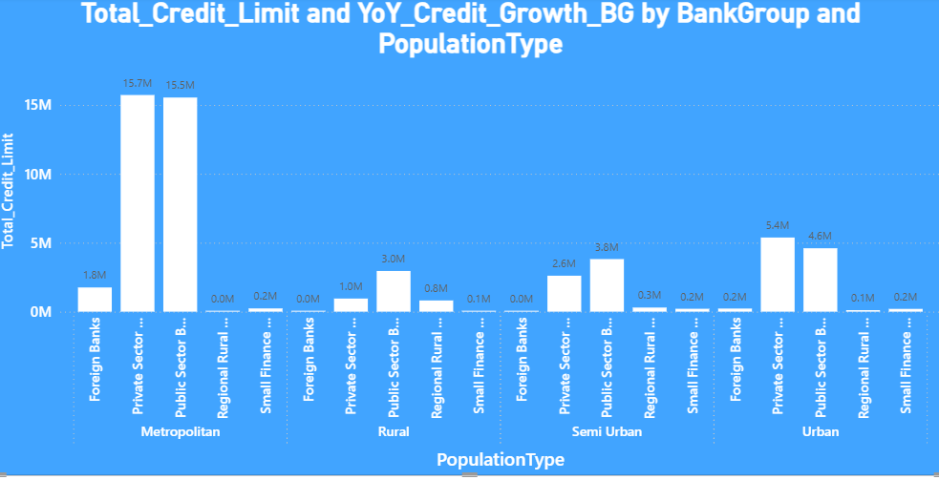
- The chart shows Private and Public Sector Banks dominate metropolitan and urban credit, while Public Sector Banks and Regional Rural Banks lead in rural areas. Metropolitan exposure is the largest concentration overall, creating geographic and counterparty concentration that requires targeted monitoring and stress testing.
- Insights:
- Metropolitan: Private Sector Banks ≈ 15.7M, Public Sector Banks ≈ 15.5M. These two bank groups together hold the vast majority of metro credit.
- Urban: Foreign Banks ≈ 5.4M, Private Sector Banks ≈ 4.6M — foreign banks have a surprisingly large urban footprint.
- Semi Urban: Foreign Banks ≈ 2.6M, Private Sector Banks ≈ 3.8M. semi-urban lending is split between foreign and private banks.
- Rural: Public Sector Banks ≈ 3.0M, Regional Rural Banks ≈ 0.8M. Rural credit is concentrated in public and regional rural banks.
- Small Finance Banks show minimal aggregate limits across all population types (≤0.2M), indicating limited scale in this dataset.
- Diversify origination into semi-urban and rural segments where credit per bank is lower, using digital channels or partnerships to scale cost-effectively.

8.6. HHI (Herfindahl–Hirschman Index)
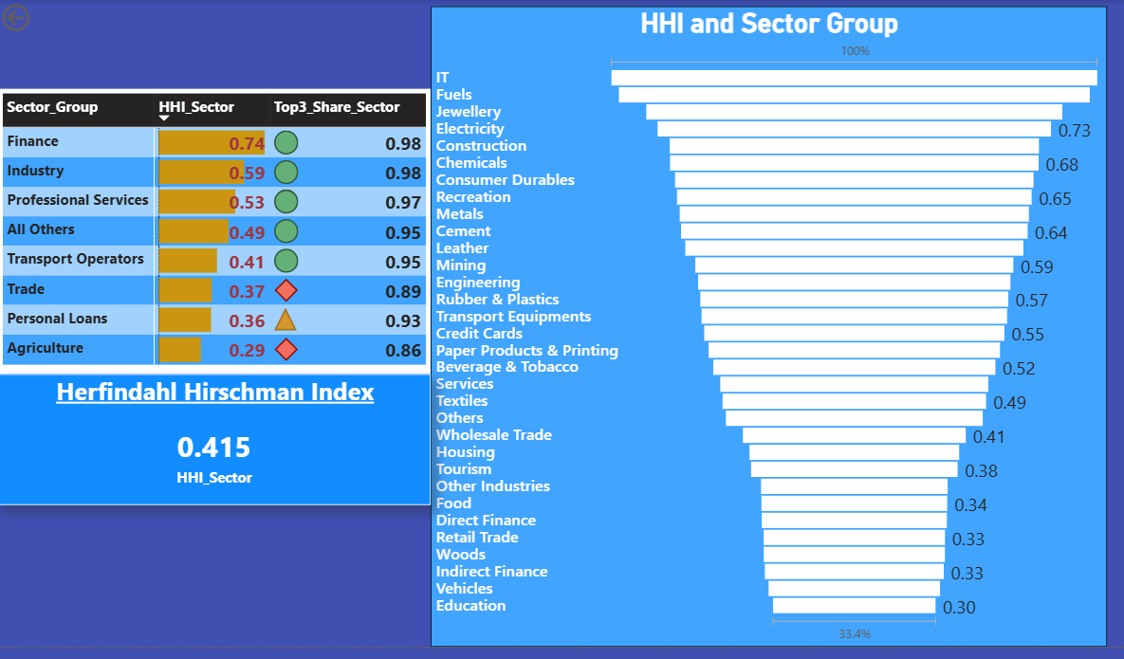
- The Herfindahl–Hirschman Index (HHI) is a standard measure of market concentration used in economics and risk analysis.
- The sector landscape is highly concentrated. A few sectors (notably IT, Fuels, Jewellery, Electricity, Construction, Chemicals, Industry, Finance) show very high HHI and Top-3 shares near or above 90%, while sectors like Agriculture, Trade, Personal Loans are comparatively more distributed. The portfolio-level HHI (~0.42) signals moderate to high concentration.
- This shows sector-level concentration using HHI and the Top-3 share. Finance, Industry, and Professional Services are the most concentrated sectors, while Agriculture, Trade, and Personal Loans are relatively more distributed.

8.7. Outstanding by Sectors
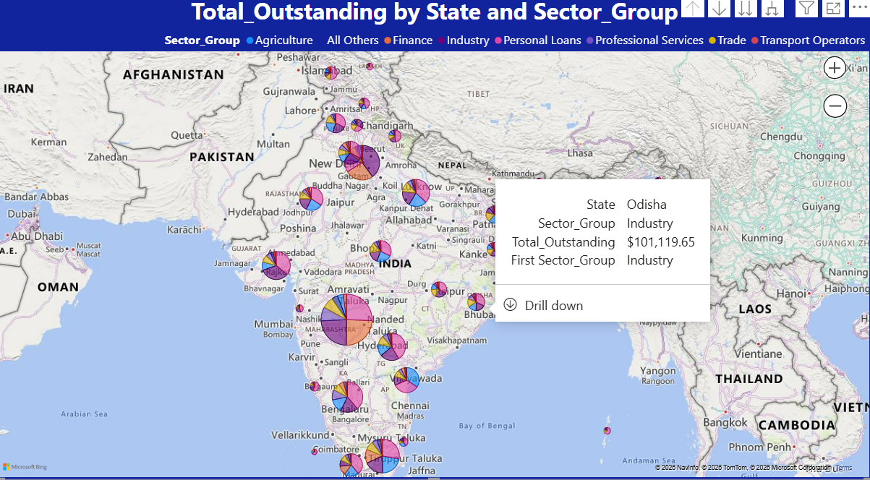
- Insights
- The outstanding portfolio is sector-skewed: a handful of sectors (notably Industry, Finance, Personal Loans, and Agriculture) drive most of the outstanding balances across states.
- Geographic distribution is uneven — a few states show large, multi-sector pies while many states have small, narrow exposures — creating both concentration risk and clear opportunities for targeted growth or remediation.
- Metro hubs concentrate multi-sector exposure — states with big urban centers show large, diversified pies but are still dominated by Industry/Finance.
- Rural and semi-urban pies are sector-specific — Agriculture and Regional Trade dominate in some states, making those states vulnerable to local shocks (monsoon, commodity prices).
- Single-sector dominance in some states suggests single-point failure risk if a major borrower or industry cluster weakens.
- Long tail of small states: many states have low outstanding; these are opportunities for low-cost digital origination or partnerships to diversify.

9. Insights & Conclusions
- Since the dataset is huge, Statistical Analysis is done by pivot table.
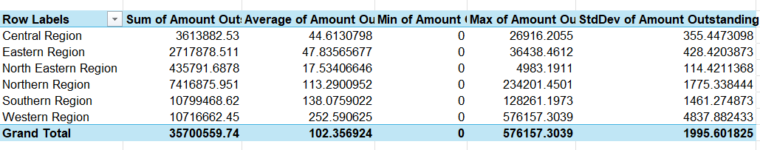

9.1. Central Tendency
- Grand Total Average Outstanding per account: ~102.36
- Highest Average: Western Region (~252.59) → indicates larger account sizes.
- Lowest Average: North Eastern Region (~17.53) → smaller account sizes.
Western Region has accounts that are, on average, ~15× larger than North Eastern.

9.2. Spread
StdDev (Volatility):
  - Western Region: ~4,837 → very high variability in exposures.
  - Northern Region: ~1,775 → also highly dispersed.
  - North Eastern Region: ~114 → relatively stable, low variability.
- Range (Max – Min):
- Western Region: 576,157 – 0 → extremely wide spread.
- Northern Region: 234,201 – 0 → concentrated large exposures.
- Other regions show smaller ranges.
- Western and Northern regions carry concentration risk (few very large accounts drive totals).

9.3. Distribution (Geographic Lending Patterns)
- Total Exposure (Sum Outstanding):
  - Southern Region: ~10,799,469 (largest share).
  - Western Region: ~10,716,662 (almost equal to Southern).
  - Northern Region: ~7,416,876.
  - Central + Eastern combined: ~6,331,761.
  - North Eastern: ~435,792 (smallest share).
  - % of Grand Total (35,700,560):
  - Lending is heavily concentrated in Southern + Western (≈60%), while North Eastern is negligible.

9.3. Key Insights
  - Top Performers (High exposure, moderate volatility): Southern Region → large exposure, but StdDev lower than Western.
  - Risky Growth (High exposure, high volatility): Western Region → largest accounts, widest spread.
  - Stable but Stagnant: North Eastern → small exposure, low volatility.
  - Concentration Risk: Northern Region → very high max exposure (234,201), suggesting dependency on a few large borrowers.

9.4. Analysis By Pivot Tables
9.4.1 CreditLimit_By_Bank_And_Sector
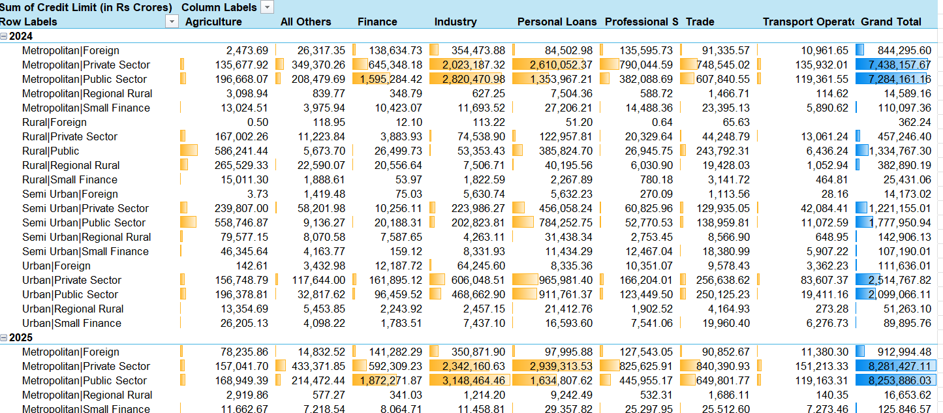
- Key Insights
- Overall Growth:
  - Total Credit Limit increased from ~₹47.4 lakh crores in 2024 to ~₹55.5 lakh crores in 2025 (≈17% growth).
- Sectoral Leaders:
  - Industry and Personal Loans dominate, together accounting for ~57% of total credit limits in 2025.
  - Finance and Trade are mid-tier contributors, while Agriculture remains relatively small.
- Institutional Patterns:
  - Public Sector Banks hold the largest share across regions, especially in Rural and Semi-Urban areas.
  - Private Sector Banks show strong growth in Metropolitan and Urban regions, surpassing Public Sector in some categories.
  - Small Finance Banks remain low players but show steady expansion.
- Regional Distribution:
  - Metropolitan regions account for the majority of credit limits, with Private and Public Sector banks leading.
  - Urban regions show strong growth, especially in Private Sector lending.
  - Rural regions are dominated by Public Sector banks, reflecting government-driven credit penetration.
  - Semi-Urban regions contribute significantly, with Public Sector banks maintaining leadership.
- Foreign Banks:
- Their share is small but concentrated in Metropolitan and Urban regions, mainly in Industry
9.4.2. Exposure By Region and Bank
- Overall Scale:
  - Total Outstanding = ₹35.7 lakh crores.
  - Metropolitan areas dominate (₹20.2 lakh crores, ~57% of total).
- Regional Leaders:
  - Western Region is the largest contributor (₹10.6 lakh crores), driven mainly by Maharashtra (~₹8.5 lakh crores).
  - Southern Region follows (~₹11.7 lakh crores), with Tamil Nadu (~₹3.3 lakh crores) and Karnataka (~₹2.6 lakh crores) as major hubs.
  - Northern Region is significant (~₹7.2 lakh crores), heavily concentrated in Delhi (~₹3.5 lakh crores).
  - Eastern and North Eastern Regions are smaller contributors (~₹2.7 lakh crores combined).
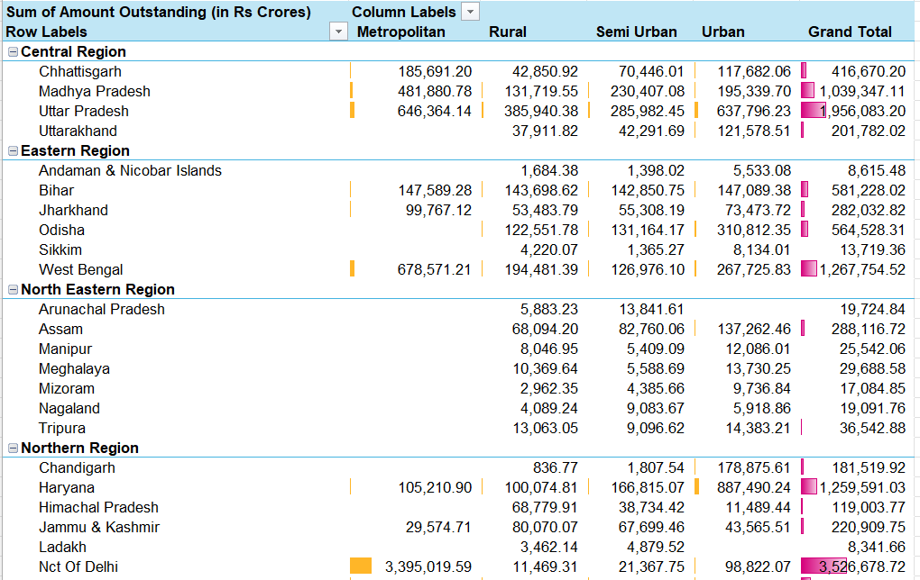
- State-Level Concentration:
  - Maharashtra, Tamil Nadu, Karnataka, Delhi, and Uttar Pradesh together account for the majority of national outstanding.
  - Kerala shows a unique pattern: very high Semi-Urban and Rural exposure (~₹1.2 lakh crores total).
- Urban vs Rural Split:
  - Metropolitan + Urban together = ~77% of total outstanding.
  - Rural + Semi-Urban = ~23%, highlighting concentration in large cities.
- Risk Concentration:
- Heavy reliance on a few states (Maharashtra, Tamil Nadu, Karnataka, Delhi, UP).
- Smaller states/UTs (e.g., Sikkim, Lakshadweep, Goa) contribute marginally.
- Summary: Outstanding credit is highly concentrated in metropolitan hubs and a handful of large states, with Maharashtra and Tamil Nadu leading. Rural and semi-urban exposure is meaningful in Kerala and parts of Eastern India, but overall, the portfolio is city-centric.
9.4.2. Analysis by Scenario Manager
Scenario Analysis Insights
- Base Scenario (GrowthFactor = 1.10, UtilizationAdj = 0.00):
  - Assumes steady growth with no change in utilization.
  - Metropolitan and Urban segments remain the largest contributors, reflecting strong credit demand in city hubs.
  - Rural and Semi-Urban segments show moderate exposure, but utilization is already high, signaling saturation risk.
- Optimistic Scenario (GrowthFactor = 1.00, UtilizationAdj = –0.02):
  - Growth is flat, but utilization decreases slightly.
  - This scenario suggests improved efficiency: borrowers are using less of their sanctioned limits, reducing risk.
  - Metropolitan and Urban segments benefit most, as lower utilization balances their high exposure.
  - Rural and Semi-Urban segments still show very high utilization, indicating limited room for expansion.
- Stress Scenario (GrowthFactor = 0.90, UtilizationAdj = +0.05):
- Growth slows, while utilization rises.
- Rural and Semi-Urban segments become particularly vulnerable, as their utilization rates spike further.
- Metropolitan exposure remains large, but stress conditions amplify volatility.
- Summary
- Metropolitan & Urban → dominate exposure; optimistic scenario reduces risk slightly, but stress conditions could magnify volatility.
- Rural & Semi-Urban → already high utilization; stress scenario pushes them into riskier territory, while optimistic scenario offers little relief.
- Portfolio Sensitivity → utilization is the critical lever: small adjustments (+/–2–5%) significantly change risk outlook.
- Strategic Implication → diversify exposure away from high-utilization rural/semi-urban accounts, and monitor large metropolitan borrowers under stress conditions.
- Scenario Sheet:
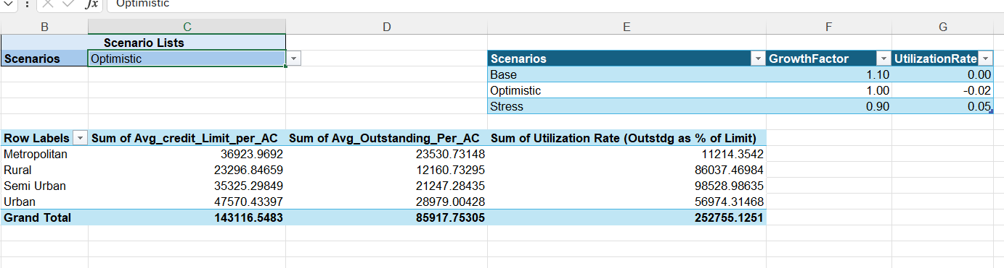
- Calculated column in Fact_credit
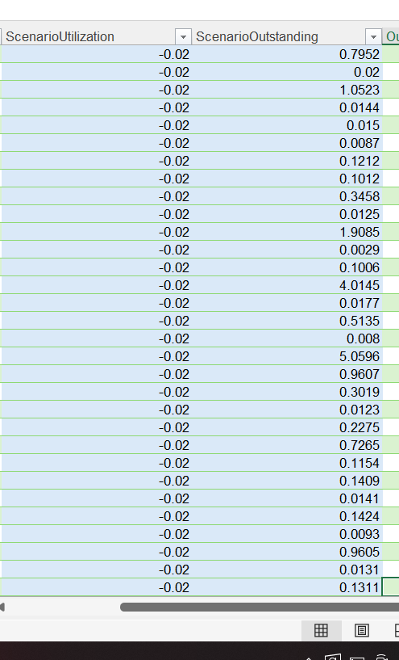

9.5. Overall Summary
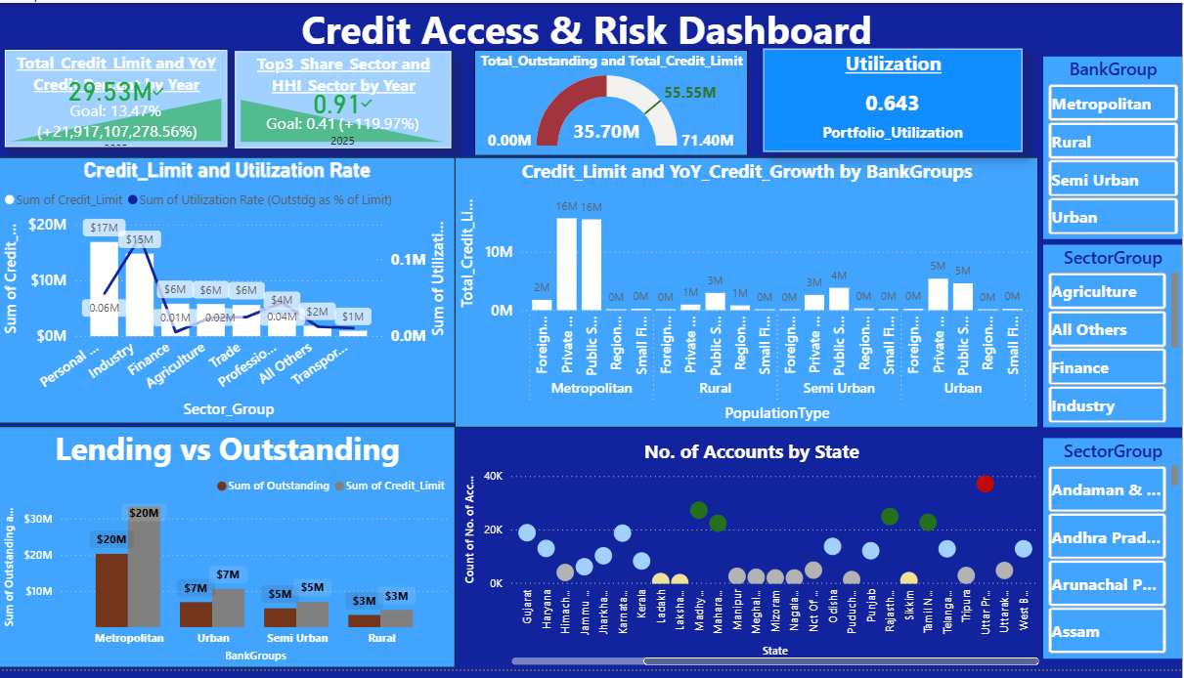
The dashboard shows a portfolio with strong growth but elevated concentration and utilization risk. Total sanctioned capacity has expanded materially, utilization is high, and a few sectors, states, and BankGroups dominate exposure — so the immediate priority is to validate drivers, quantify concentration, and run targeted stress tests.
- Portfolio Utilization: ~0.64 (64%) significant drawdown of sanctioned lines.
- Portfolio HHI: ~0.42 moderate-to-high concentration at sector level.
- Top-3 Share Sector: the three players Industry, Personal Loans and Finance dominate many sectors.
- Segment concentration: Metropolitan and Industry/Finance sectors are the largest buckets; Personal Loans and Agriculture are material but smaller.

9.6. Diagnosis Summary · Operational View · Forecast
- Rapid sanctioned growth with high utilization (~64%) and elevated concentration (HHI ≈ 0.42); outstanding is heavily drawn and metro/Industry/Finance are the primary hotspots.
- That makes the portfolio fragile—there’s little spare capacity and too much reliance on a few players.
- If unchanged, expect rising delinquencies and higher volatility within 3–6 months; a 20–30% non-renewal or shock to top contributors would produce material portfolio stress.

10. Conclusion
The portfolio is large, growing, and heavily concentrated in metropolitan hubs and a few states, with Industry and Personal Loans as the main sectors. While growth is strong, the volatility and concentration risk in Western/Northern regions and the urban bias of lending highlight the need for diversification into rural/semi-urban markets and broader sectoral balance.

